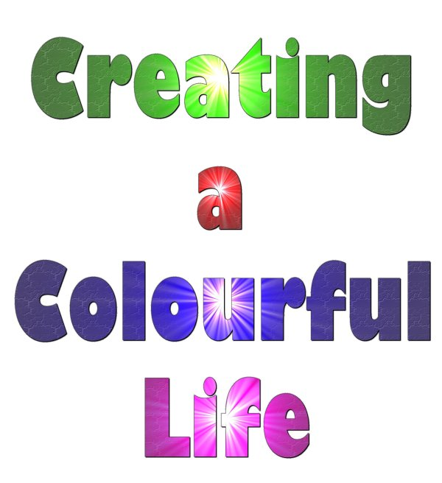

Professional Development in Science for KS3 Teachers




Creating a Colourful Life is a project aimed to raise the profile of Chemistry by using pigment science in schools and at Universities. The science of colour links to numerous aspects of the National Curriculum.

The objectives of the day are to:
- develop good subject knowledge in Science
- run through ideas for Science activities which meet National Curriculum requirements and use easy access equipment
- provide resources ready to use in the classroom

This booklet is designed to provide KS2 teachers with ideas and resources to teach some parts of the Science National Curriculum.

There are five different activities.

For each activity there is:

- a lesson planning sheet: this outlines the links to the National Curriculum with clear Learning Outcomes, provide some background information along with a lesson plan, a list of the resources required and the answers to the questions for the student worksheet.

- a “handout” worksheet. This contains the instructions for the pupils to follow and questions related to the subject.

This has been developed to be easy to fit into exiting schemes of work or project. It is intended to be easily modified and adapted to the users own needs.

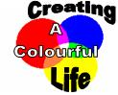
Smart pigments Key stage 3 Lesson Planning

Scheme of work unit Light (visible spectrum)

National Curriculum link

Energy can be transferred usefully, stored, or dissipated, but cannot be created destroyed.
Learning outcomes
Describe the change in colours of a painted mug in terms of absorbed and reflected light.
Introduction notes
THERMOCHROMIC paint is a relatively recent development in the area of colour-changing pigments. After absorbing a certain amount of HEAT, the crystal or molecular structure of the pigment reversibly changes. It then absorbs and reflects light at a different wavelength (hence a different colour) than at lower temperatures.

Thermochromic paints are seen quite often as a coating on coffee mugs, whereby once hot coffee is poured into the mugs, the thermochromic paint absorbs the heat and becomes colored or transparent, thus changing the appearance of the mug.

Suggested Lesson Plan:

Starter

Discuss why we see the world in colour (spectrum of light, white light, some colours are absorbed some colours are reflected depending on their wavelength)

Demo heating up one mug to show change in colour. Explain what happens.

Possibility to link to an investigation: How could they prove that it is the heat that causes the colour change and not the air blowing on the cup?

Main Activity

Students paint a mug using thermochromic paint

Plenary

What are photochromic paints? Predict what would cause this kind of paint to change colour.

Could be used as a research activity (part of main activity if computers are available in the room)

Resources required:

- Bisque pottery (one per person) www.bisqueuk.com
- Thermochromic paint
- Acrylic base
- Glow-in-the-dark paints
- Paintbrushes
- Example mug
- Heat gun (hair dryer)

Health and Safety
This pottery is unglazed; it cannot be used for the consumption of food or drink.
A coat of varnish can be applied to improve durability of all items.

Further Work
Research other uses of thermochromic paints and other kinds of paints and how they work.

Answers:

- As used
- Some colours are absorbed i.e. all of the colours of the spectrum except the one they can see reflected.

Smart Pigments

Practical

Paint Your Own Pottery

You will need:
- unglazed bisque pottery
- thermochromic paint
- paintbrushes

Instructions:
- Paint your pottery using the paintbrushes provided and your choice of paint and design.
- If you want to see your pottery change colour with heat ask a teacher to heat it with a heat gun.
- If you want to see any glow in the dark paint working, place your pottery in the dark box.

NOTE: This pottery is unglazed; it cannot be used for the consumption of food or drink. A coat of varnish can be applied to improve durability of all items.

Questions

- What colours did you use to paint your pottery?

.............................................................................................................................

- Explain why your pottery appears coloured to you using the key words spectrum, absorbed and reflected.

.............................................................................................................................

.............................................................................................................................

.............................................................................................................................

.............................................................................................................................
CSI: Colours in ink Key stage 3 Lesson Planning

Scheme of work unit: Particle theory and separation techniques

National Curriculum link

Chemical and material behaviour
The particle model provides explanations for the different physical properties and behaviour of matter
Learning outcome:

Decide who could have committed the crime using the results of the investigation (separate out the colours in ink using chromatography)

Introduction notes:

- Chromatography is the collective term for a family of laboratory techniques for the separation of mixtures.
- Paper chromatography is an analytical technique for separating and identifying mixtures that are or can be coloured, especially pigments.
- The technique is based on a small concentrated spot of the sample being applied to a piece of chromatography paper about 1cm from the base.
- The paper is then dipped into a suitable solvent, such as ethanol or water.
- The solvent moves up the paper by capillary action. As the solvent rises through the paper it meets and dissolves the sample mixture, which will then travel up the paper with the solvent.
- Different compounds in the sample mixture travel at different rates due to different solubility in the solvent, and are thus separated out on the paper.

Information:

- Washable pens are used in this activity because the pigments in the inks are soluble in water.
- Inks may appear to be a single colour, but are often composed of differently coloured pigments. Water can dissolve these pigments to effect a separation and produce a decorative pattern.
- The filter paper functions as a stationary phase on which the separation takes place, whereas the water functions as a mobile phase to carry the pigments through the filter paper.
- Although colours of different manufacturers may appear to be the same, often different pigments and different ratios of pigments are used to produce the same colour. Thus, it is possible to tell what type of pen was used.

Lesson Plan:

Starter

Add a few drops of ink to water. Discuss with the class what happens to the ink. Opportunity to reinforce key words (soluble/insoluble/dissolve/mixture). Could discuss how the ink could be separated from the water again (review filtration evaporation).

Use sticky dots to show mixture of ink in water (blue dots for water particle and another colour for ink particles). Students should use their knowledge of the particle theory to show the arrangements of the particles (the sticky dots) before and after the ink has been added. Use key words to label their diagrams.

Main Activity

Students use chromatography to separate the colours in the ink of two different pens and compare these to the pen used by the thief in order to identify who committed the offence.

Worksheet available with instructions and questions.

Plenary suggestions

Discuss the answer to question 4 and what CSI teams have to consider to convict a suspect. Opportunity to introduce or develop understanding of “How Science Works” key words. Is the evidence enough? Are the results reliable? Accurate? Conclusive?

If sticky dots have been done as a starter: Discuss how they could improve their model now (the idea is that they say they should use more than one colour to represent the ink particles) and how could they model what happened during the chromatography (one coloured dot at a time dissolved in the water).

Discuss other uses of chromatography (examples of use of chromatography: use to see if a blood sample contains alcohol/use to identify the amount of pollutant in a water sample)

Resources required:

- 3 sample containers
Containers should ideally be long and thin – we have successfully used sample vials.
- Plastic pipettes
- Filter paper
- Scissors and a pencil
- Water
- A ransom note (labelled as Evidence No: 080)
- 2 different black pens (labelled as Evidence No: 081 & 082)
- Envelopes with the address “George Bloggs, 4 Anystreet, Anytown”, written on them using one of the pens. This is illustrated on the top of the next page.
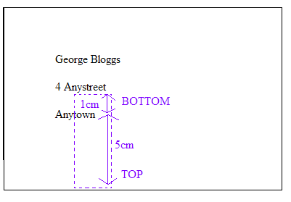
The area to be cut from the envelope needs to be of similar size to the filter paper.

The ink should be about 1cm from the bottom of the rectangular piece of paper and there should be plenty of paper above for the ink to travel up.

Labelling the top and bottom in pencil should avoid confusion.

Health and safety

Caution with glassware

Further Work

A similar practical investigates the colours in food dyes using chromatography.
Link to other separation techniques, such as separating out the pigments in leaves.

Answers for worksheet:

1-3 As observed, depending on pens used
4. No. Pens are pretty common and so it is not definite that they committed the crime.
5. Black ink is made of a mixture of different colours inks.
Each colour has a different solubility in water.
The colour most soluble in water leaves the highest mark on the paper as it dissolves first in the water.

CSI: Colours in ink

Introduction

A crime has been committed and it is up to you to solve the mystery! At 17:00 hours, George Bloggs returned home to find that his CD player had been stolen. A ransom note (Evidence No: 080) had been posted through the door of his house, 4 Anystreet, Anytown, demanding a DVD for the safe return of his CD player.

George Bloggs suspected his best friend John Smith or brother, Tim Bloggs, may have been the thief. After a search of both suspects houses, two black pens were found which may have been used to write the address on the envelope (Evidence No: 081 from John Smith’s house and Evidence No: 082 from Tim Bloggs’ house).

By separating out the colours found in the black ink of the two pens, it is up to you to solve the crime. You have to match the pen found in the suspects’ houses with the one used to address the envelope. Can you solve the crime?

Practical

1. Add 1-2ml of water to each of the 3 sample containers
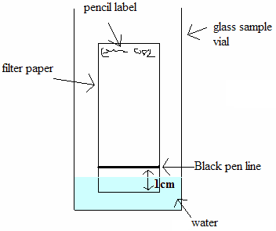
2. Label a piece of filter paper at the top in pencil with the evidence number; 081, and then a separate piece of filter paper with the evidence number 082.
3. Gently draw a horizontal line with the black evidence pen, 081 on the ‘081’ labelled filter paper, 2 cm from the bottom.
4. Do the same with evidence no. 082 on the ‘082’ labelled filter paper.
5. Carefully cut around the dotted pencil line on the envelope with the scissors.
6. Place both filter papers and the piece cut from the envelope upright into the vials, as shown in the diagram.
7. Wait at least 10 minutes and examine the colours.

Questions

1- What has happened on the filter paper?
………………………………………………………………………………………………………………………………………………………………………………………………………………………………………………………………
2- Do the colours produced by evidence 080 (the envelope) match the colours produced by one of the black pens 081 or 082?
……………………………………………………………………………………
3- Which pen appears to have been used to write the address on the envelope?
……………………………………………………………………………………
4- Is the evidence conclusive enough to accuse the owner of the pen?
…………………………………………………………………………………………………………………………………………………………………………
5- Explain why the black ink has a produced the pattern you see on the filter paper.
………………………………………………………………………………………………………………………………………………………………………………………………………………………………………………………………

Food Dye Experiment Key stage 3 Lesson Planning

Scheme of work unit: Particle theory and separation techniques

National Curriculum link

Chemical and material behaviour
The particle model provides explanations for the different physical properties and behaviour of matter

Learning outcome:

Decide what could be the cause of hyperactivity using the results of the investigation (separating out colours within food dyes using chromatography).

Introduction notes:

- Chromatography is the collective term for a family of laboratory techniques for the separation of mixtures.
- Paper chromatography is an analytical technique for separating and identifying mixtures that are or can be coloured, especially pigments.
- The technique is based on a small concentrated spot of the sample being applied to a piece of chromatography paper about 1 cm from the base.
- The paper is then dipped into a suitable solvent, such as ethanol or water.
- The solvent moves up the paper by capillary action. As the solvent rises through the paper it meets and dissolves the sample mixture, which will then travel up the paper with the solvent.
- Different compounds in the sample mixture travel at different rates due to different solubility in the solvent, and are thus separated out on the paper.

Information:

- About 2.5% of children are sensitive to tartrazine.
- Additives are required to provide safe, appealing and convenient food all year round.
- Consumers often choose stronger and brighter colours made synthetically over natural colours, which in turn encourages more food manufacturers to use these colours.
- The E in E-numbers is short for European Communities. E numbers are issued after a large number of safety tests and expert scrutiny. All approved additives are given an E-number.
- E-numbers between 100-180 are colouring additives.
- Tartrazine should be avoided by asthmatics.
- Some E-numbers are naturally occurring vitamins required by everybody. E.g. E101 is vitamin B2.

Lesson Plan:

Starter

Add a few drops of ink to water. Discuss with the class what happens to the ink. Opportunity to reinforce key words (soluble/insoluble/dissolve/mixture). Could discuss how to separate the ink from the water again (review filtration evaporation).

Use sticky dots to show mixture of ink in water (blue dots for water particle and other colour for ink particles). Students to use their knowledge of particle theory to show the arrangements of the particles (the sticky dots) before and after the ink is added. Use key works to label their diagrams.

Main Activity

Students use chromatography to separate the colours in different food dyes in order to identify what caused the boy to be hyperactive after he eats cake.

Worksheet available with instructions and questions.

Plenary suggestions

If sticky dots have been done as a starter: Discuss how they could improve their model now (the idea is that they say they should use more than one colour to represent the ink particles) and how could they model what happened during the chromatography (one coloured dot at a time dissolved in the water).

Discuss other uses of chromatography (examples of use of chromatography: used to see if a blood sample contains alcohol/used to identify the amount of pollutant in a water sample).

Resources required

- 4 strips of filter paper
- 4 sample containers
Containers should ideally be long and thin – we have successfully used sample vials.
- Samples of red, green, blue and yellow food colouring (not natural)
- Pencil
- Water
- Plastic pipettes

Health and safety

Caution with any glassware

Further work

Link to other separation techniques, such as separating out the pigments in leaves.

Answers for worksheet:

1. Paul is also sensitive to green food colouring (a mixture of yellow and blue).
Note: The yellow in the red food colouring is a different yellow.
2. Tatrazine.
Food Dye Experiment

Introduction

Paul was a lively kid. He enjoyed all the normal things that kids enjoy doing. However one day his mother, Mandy, noticed that whenever he ate fairy cakes with his favourite yellow coloured icing on top he was more lively than normal. She mentioned this to one of her friends, who said that some children are sensitive to some types of food. Yellow food colouring is known to cause some children to become hyperactive.

This made sense to Mandy, so she decided to avoid yellow food colouring. It was Paul’s birthday, and so to stop him becoming hyperactive when she made his birthday cake she decorated it with red, green and blue icing. However on his birthday Paul was still hyperactive after eating the cake.

Being a scientist, Mandy knew that colours could be mixed to make new colours. She decided to find out if yellow food colouring was used in other food colourings. This is the experiment she carried out. What results did she find?

Practical

- Place 1-2 ml of water into each of the 4 sample containers.
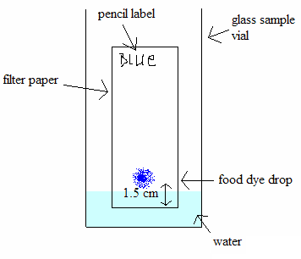
- Label each piece of filer paper at the top in pencil with the food colour to be tested.
- Use separate pipettes each time (to avoid contamination). Place one drop of food colour approximately 1.5cm from the bottom of each of the labelled filter papers
- Place each filter paper upright into a different vial as shown in the diagram.
- Wait at least 10 minutes and examine the colours.
Questions

1- Which other food colouring(s) is Paul sensitive to and how do you know?
……………………………………………………………………………………
……………………………………………………………………………………
……………………………………………………………………………………
2- Can you identify which substance Paul is sensitive to?
…………………………………………………………………………………………………………………………………………………………………………

Invisible Ink Key stage 3 Lesson Planning

Scheme of work unit Acid and alkali - pH scale - Indicators

National Curriculum link

Range and content of Science key stage 3

Chemical and material behaviour
Elements and compounds show characteristic chemical properties and patterns in their behaviour. Use examples such as acids and alkalis.
Learning outcomes
Identify acids and alkalis (properties and uses).
Classify solutions as acidic, alkaline or neutral using indicators.
Compare the acidity and alkalinity of different solutions using the pH scale.
Predict what happens when acids and alkali are mixed (concept of neutralisation).
Introduction notes
- Commonly acids and bases are used as invisible ink, and these are subsequently revealed by indicators.
- Indicators are chemical compounds which are different colours when in contact with either acids or bases.
- Indicators are also used in chemistry to show when chemical reactions are finished.
- An acid is traditionally considered any chemical compound that, when dissolved in water, gives a solution with a pH less than 7.0, with the generic formula HA[H⁺A⁻].
- Common examples include acetic acid (in vinegar) and sulphuric acid (in car batteries).
- Generally acids have the following properties:
Taste: Acids generally have a sour taste.
Touch: Strong or concentrated acids often produce a stinging feeling.
Reactivity: Strong acids react aggressively with or corrode many metals.
Electrical Conductivity: Acids, while not usually ionic compounds are electrolytes.
Acids turn litmus paper red.
- Most commonly bases are thought of as a substance that can accept protons.
- Common examples are sodium hydroxide and ammonia.
- Bases can be thought of as the chemical opposite of acids.
- This is because the effect of an acid is to increase the hydronium ion concentration in water, and the effect of a base is to reduce it.
- A reaction between an acid and base is called neutralization.
- Bases react with acids to produce water and salts (or their solutions).
- Generally bases have the following properties:
Taste: Bitter taste
Touch: Slimy or soapy feel on fingers
Reactivity: Caustic on organic matter, react violently with acidic substances.
Electrical conductivity: Aqueous solutions or molten bases dissociate in ions and conduct electricity.
Bases turn litmus paper blue.

Suggested Lesson Plan:

Starter
Students find examples of acids and bases/alkaline substances at home.
Use their answer to establish facts about acids and bases and to clarify any misconception. Both acids and bases can be dangerous (car acid/oven cleaner) and both can be used at home (vinegar/soap, toothpaste). It is the strength or concentration of the solution that makes a solution dangerous, not whether it is an acid or a base.

Main Activity

Pupils prepare an acidic solution (lemon juice) and an alkaline solution (bicarbonate soda) and write an invisible message on filter paper with these two solutions.
They then prepare the indicator solution (with red cabbage) which is used to reveal the message.

Worksheet with practical procedure and questions to be given out. (Note that question 4 involves previous knowledge on elements and compounds/chemical reactions)

Possible extension:
If time allows students could use the indicator to test the solutions from question 5.

Plenary
Discuss how antacid tablets work.

What could you try to put on a wasp sting (alkali) and on a bee sting (acidic) to relief the pain? Argue why it could work (neutralisation) and why it wouldn’t (unknown concentration and volume compared to the venom unlikely to achieve perfect neutralisation, venom has been injected under the skin and spread into the body via blood stream whilst vinegar or bicarbonate of soda are poured onto the skin.) (→ link to Scientific Concepts- Critical analysis)

Resources required:

- Diced red cabbage
- Lemon
- Bicarbonate of soda
- Warm water
- Pestle and Mortar (or similar)
- Sieve
- Paper
- Plastic cups or containers
- Paint brushes
- Spotting tiles, pipettes and samples of Vinegar , Coca Cola, Deionised Water , Tap water, Soap, Lemon, Lime Water, Bleach (for possible extension 1)
- Filter paper and funnel (for possible extension 2)

Health and Safety

Care needs to be taken to ensure the water is not too warm as to scold the pupils.

Further Work

Investigate the use of other readily available materials as invisible inks. Explore which are acids and which are bases.
Use indicators to classify unknown solutions as acidic, alkaline or neutral.

Answers:

- Indicators are chemical compounds which are different colours when in contact with either acids or bases.
- Acidic
- Bases react with acids. A neutralisation reaction happens.
- Vinegar – Acidic
Coca Cola – Acidic
Water – Neutral
Soap – Basic
Lemon – Acidic
Lime Water – Basic
Bleach – Basic
- Use an indicator, e.g., Methyl Orange, or use Litmus paper.
- HCl_{(aq)} + NaOH_{(aq)} → H₂O_{(l)} + NaCl_{(aq)}

Invisible Ink Experiment

Introduction

Invisible inks are used to send secret messages. Typically a secret message is hidden within an ordinary letter and can be revealed by the receiver using a known procedure. A secret message has the advantage over a coded message in that people intercepting the mail would have no idea that a message was being sent. However, a plausible cover is needed to hide the secret message (a blank piece of paper would arouse suspicion!)

An ideal invisible ink should be easily made, hard to detect and easily and safely revealed. Invisible inks are normally non-greasy and not visible under UV light (a common screening method for post).

Commonly acids and bases are used as invisible inks, and these are subsequently revealed by indicators. Indicators are chemical compounds which are different colours when in contact with either acids or bases.

In addition to indicators, heat can also be used to reveal messages. A substance applied to the paper that burns at a lower temperature than the paper and the message is revealed.

Practical

- Squeeze some lemon juice into a container. In a different container dissolve some bicarbonate of soda with some warm water. Stir well – it does not matter if it is not completely dissolved.

- Use different brushes to apply both the lemon juice and bicarbonate of soda solution to separate pieces of paper. It is important that you allow both to dry thoroughly before you can reveal your messages.

- Red cabbage contains a natural indicator which can be used to reveal messages. Mash the diced red cabbage and warm water in a pestle and mortar. You should get a dark purple solution. This will be your indicator.

- Apply your indicator over the top of the messages you originally created using a paintbrush.


Questions

1- What is an indicator?

…………………………………………….……………………………………………………

…………………………………….……………………………………………………………

2- Is the lemon juice acidic or basic?

...................................................................................................................................................

3- What happens when an acid and a base react together? What is the name of this reaction?

……………………………………………………………………………….…………………

………………………………………………………………………….………………………

4 - Next to each of these everyday items, write down whether they are acidic, neutral or basic:

  - Vinegar …………….
  - Coca Cola …………….
  - Water …………….
  - Soap …………….
  - Lemon …………….
  - Lime Water …………….
  - Bleach …………….

5 - How could you test whether you were correct about them being acidic, neutral or basic?

…………………………………………………….……………………………………………

…………………………………….……………………………………………………………

6 - When neutralisation happens, water is produced. Write an equation for the reaction of sodium hydroxide with hydrochloric acid:

……………………………………….…………………………………………………………

Ancient Art Practical Key Stage 3 Lesson Plan

Possible links to scheme of work unit: Introduction to the Rock Cycle
Particle model/ solutions/Change of state

National Curriculum link:

Range and content of Science key stage 3

3.4 The environment, Earth and universe
- geological activity is caused by chemical and physical processes

3.2 Chemical and material behaviour
- the particle model provides explanations for the different physical properties and behaviour of matter

Learning outcomes:

Rock cycle:
State that there are different sorts of rock with different characteristics and that pebbles and soils from different rocks consequently have different characteristics.
Explain how rocks are continuously been destroyed, transformed and reformed.

Particle model:
Discuss properties of solids, liquids and gases. Link these properties to science applications and how materials are chosen for a particular use.

Information:

- Cave paintings have been found throughout the world, from dark limestone caves in the South of France to rock shelters in Zimbabwe.
- Cavemen had limited knowledge about pigments, and few tools with which to make them. So they used the minerals around them to obtain colours.
- They would grind the minerals to a fine powder, and then use saliva, ear wax or animal fat to make the paint stick to the surface.
- They used chewed twigs as brushes.
- By the time of the Ancient Egyptian era, there were more colours available. These were made by heating natural materials.
- The Egyptians traded new brightly coloured minerals, such as Saffron. The Egyptians also developed better tools to grind them with.
- Egyptians found ways of extracting sap from plants, as well as using milk from cows to bind their pigments together to form paint.
- By Medieval times, people travelled and traded even more widely across Europe. A large variety of colours were now becoming available.

Suggested Lesson Plan:

Starter

Rock cycle:
- Have a powerpoint slide with a picture of Lapis Lazuli (mineral), Cochineal (insect producing red pigment carmine), Annatto (plant used to produce red food colouring), Indigo (plant once used to produce the blue for jeans), berries, charcoal (used for black colouring by cave men) and ask the students what they all have in common.

- Discuss how cavemen painted pictures on cave walls. Link this to present day and the fact that we haven’t “run out of rocks”. Discuss ideas of rock cycle.

Particle model:
Compare a large bit of chalk, chalk powder and chalk powder in water. Discuss state and change of state.

Main activity

Pupils to compare paints made from natural materials and modern day paints.

Then pupils make their own paint and use it to paint a picture or something else (they could paint a model volcano that they would have previously made - once the paint is dry they could erupt their volcano with vinegar and bicarbonate soda).

Worksheet with questions.

Plenary

Rock cycle:
Discuss what properties of the rocks would have required for cavemen to be able to make paint and link to selective use (texture/appearance/hardness/colour etc). This could be used to link to different kinds of rocks and their properties (following lessons).

Particle model:
Discuss properties of the pigment and binder. Discuss if you could separate the pigments and the binder again. Discuss what new properties the paint has that is useful. Compare and contrast the colours obtained naturally with the man-made pigments available today. Suggest reasons for making chemical pigments instead of using natural sources.

Resources Required:

For detailed information about sourcing the materials please see our resources sheet. http://www.creatingacolourfullife.co.uk/download/resourcelist.pdf

For this experiment it is only necessary to have an example of a natural pigment and one of a man-made pigment.

- Natural pigment (Ancient): Iron Oxides (yellow, red)
Malachite
Chalk Rock
Ultramarine Blue
Chalk Sticks
- Man-Made pigment (Modern): Powder Paints
- PVA Glue
- Eggs (Optional)
- Pestle & Mortar (if grinding is required)
- Plastic Cups
- Spoons
- Paint Brushes

Health and safety:

If using eggs as a binder, be sure there are no allergies towards them.
Care must be taken when grinding the ancient materials.

Further Work:

Pupils can make their own “cave chalk stick” using egg shells. Information about this is available on our website – www.creatingacolourfullife.co.uk under the experiments section. Relates to the concept that materials can be mixed together to form a new, usable item.

The ancient and modern paints that the children have made can be used to make a display, outlining what they have learned.

Answers worksheet:

- Minerals and rocks
- Spit, animal fat and/or ear wax.
- Browns, dark oranges, dark reds.
- Modern day paints are a lot brighter. Much wider selection of colours.
- Paint pigment: Dry, fine powder, not sticky, solid.
Binder: Very sticky, viscous, liquid.
- Sap from plants and milk from cows.
Ancient Art Practical

Introduction

Cave paintings have been found throughout the world. Cavemen had very few tools available to them, and they had to use the minerals and rocks around them to obtain colours. They would dig these minerals and rocks from the ground and then grind them into a fine powder.
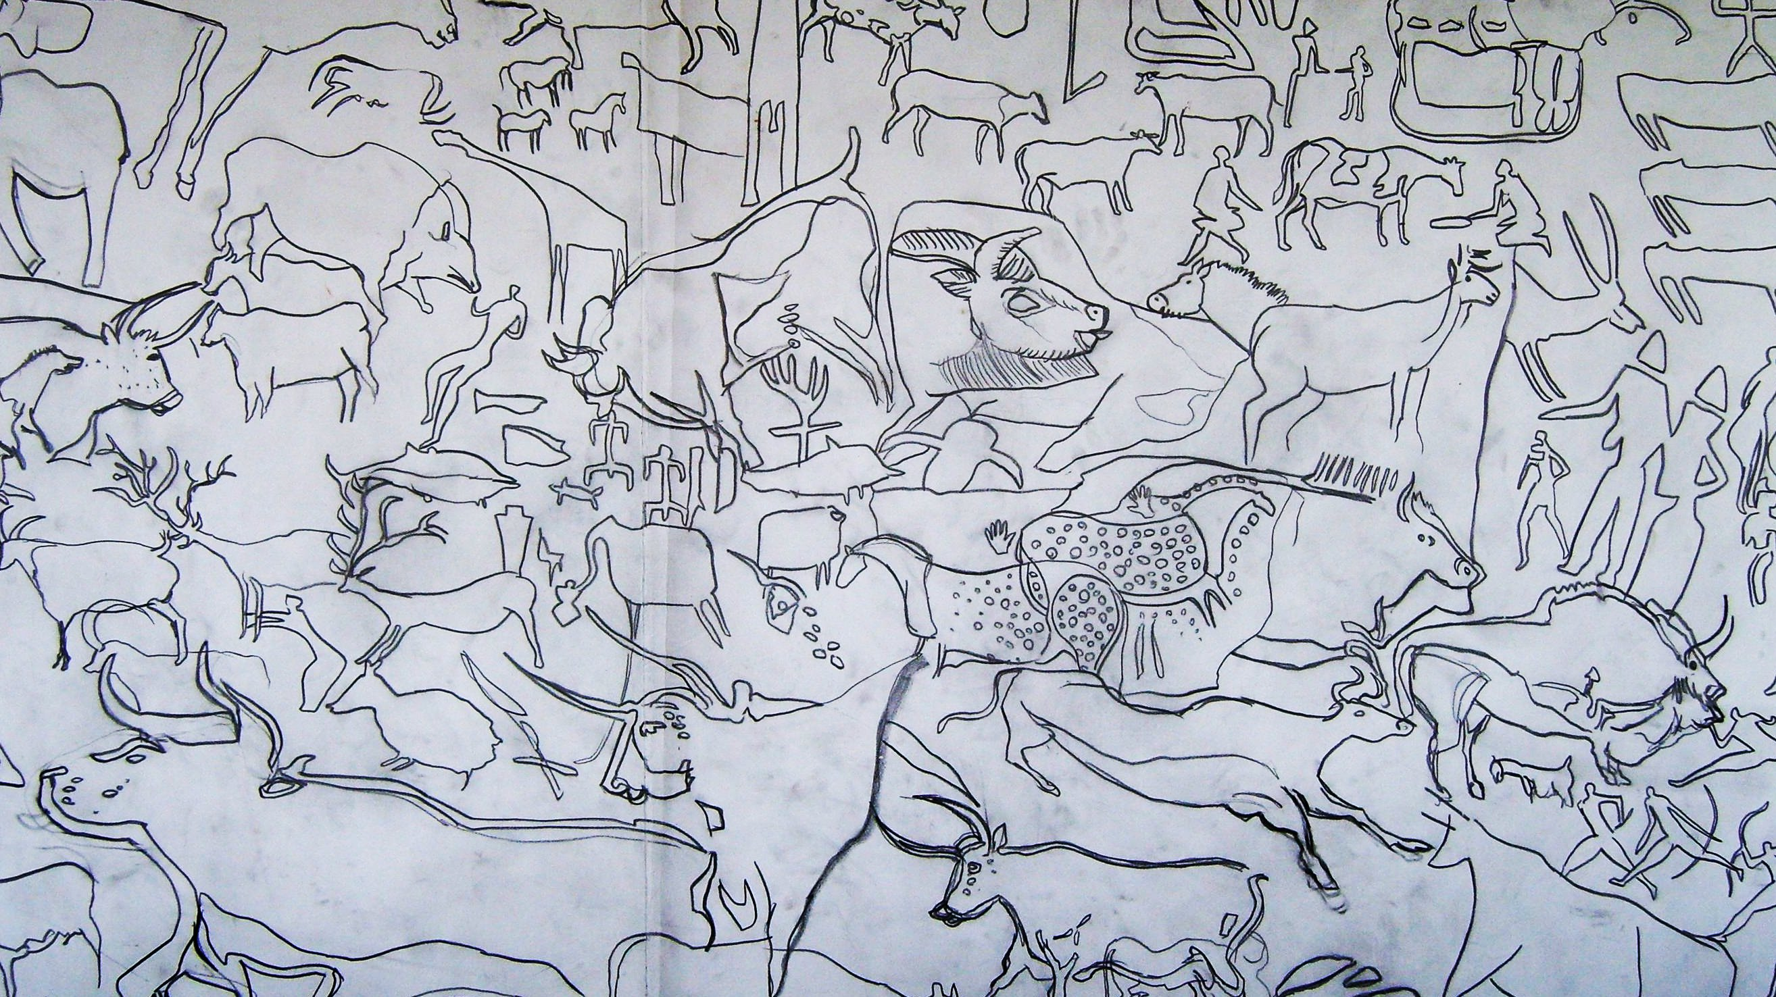

Modern cave art drawing.

The cavemen would use their spit, animal fat or ear wax to make their paints stick to the cave walls.

Cavemen would also use their fingers and the end of chewed twigs to paint their pictures with.

By the time of the Ancient Egyptian era there were more colours available. They found new brightly coloured minerals, and better tools to grind them with.

Egyptians found ways of extracting sap from plants, as well as using milk from cows to bind their pigments together to form paint.

By Medieval times people travelled and traded even more widely across Europe. A large variety of colours were now becoming available.

In this practical you will pretend that you are a caveman, and use natural materials in order to paint pictures, just like the cavemen did. You will also paint pictures using modern day paints and compare the colours.
Practical:

- Look at both the natural pigments and the man made pigments. What are the differences between them? Which is your favourite pigment?
- Add a teaspoon of your favourite pigment to a plastic cup. If you are using a natural material, make sure it has been ground to a fine powder first.
- Add a few drops of water and mix with a brush until you have a smooth paste.
- Separate the egg yolk from the egg white and dispose of the egg white. Add the egg yolk to your plastic cup. (If you are using PVA glue, add 2 teaspoons of it to the plastic cup instead).
- Mix the egg yolk with your pigment paste using a paint brush.
- You are ready to paint.

Questions:

- What did the cavemen use to make their paints?

……………………………………………………………………………………………………

……………………………………………………………………………………………………

- How did cavemen make their paints stick to the cave walls?

……………………………………………………………………………………………………

- Which colours did the cavemen have to paint with?

……………………………………………………………………………………………………

- What are the differences between the ancient cavemen paints and the modern day paints?

……………………………………………………………………………………………………

……………………………………………………………………………………………………

- What are the properties required to make a good binder?

……………………………………………………………………….…………………………...

……………………………………………………………………………………………………

- What did the Egyptians use to bind their pigments together to form paint?

……………………………………………………………………………………………………

……………………………………………………………………………………………………

Chemical Pigments Experiment Key Stage 3 Lesson Plan

Scheme of work unit: Chemical change.
Separation techniques (filtering)
Elements, compounds and mixtures

National Curriculum link:

Range and content of Science key stage 3

Chemical and material behaviour
- the particle model provides explanations for the different physical properties and behaviour of matter
- elements consist of atoms that combine together in chemical reactions to form compounds
- elements and compounds show characteristic chemical properties and patterns in their behaviour.
Learning outcomes:

Identify the various signs of a chemical reaction taking place during the formation of pigments.
Decide what technique to use to separate the newly formed solid from the solution.
Explain the differences between compounds and mixtures.

Introduction notes:

- A pigment is a small particle that does not dissolve in water.
- Pigments can be natural or man-made. (examples of natural pigments are Lapis Lazuli (mineral), Cochineal (insect producing red pigment carmine), Annatto (plant used to produce red food colouring), Indigo (plant once used to produce the blue for jeans)
- A pigment is insoluble in the solvent; a dye is soluble in its solvent.
- Malachite Green is a chemical that is primarily used as a dye.
When diluted, Malachite Green can be used as a topical antiseptic or to treat parasites, fungal infections and bacterial infections in fish and fish eggs. It is also used as a bacteriological stain

- Prussian Blue is a dark blue pigment used in paints and formerly in blueprints.
Despite being one of the oldest known synthetic compounds, the composition of Prussian Blue was uncertain until recently. The precise identification was complicated by 3 factors:
(i) Prussian Blue is extremely insoluble but also tends to form colloids (a suspension of particles in a liquid).
(ii) Traditional syntheses tend to afford impure compositions.
(iii) Even pure Prussian Blue is structurally complex, defying routine crystallographic analysis.
The chemical formula of Prussian Blue is Fe₇(CN₁₈)(H₂O)_{x}

Suggested Lesson Plan:

Starter
Chemical change and Separation techniques (filtering)
Demo: Add a magnesium ribbon to a solution of hydrochloric acid. This could be used as a starting point to discuss the signs of a chemical reaction taking place in this case (effervescence, substance disappeared, exothermic reaction). Could be extended to other possible signs or these could be what the students have to find out in their practical (in the case of making pigments they will observe: change of colour, new substances formed and effervescence for Malachite Green)

Elements, Compounds and mixtures
Demo: Iron fillings and Sulfur mixture. Use magnets to separate.
Same mixture heated (care must be taken. Sulfur dioxide fumes may trigger asthma attacks - use fume cupboard). Compounds are formed (iron sulfide) and the magnet cannot separate the iron from the sulfur anymore (use a weak magnet as it doesn’t work all the time). Discuss the differences between compounds and mixtures and changes in their properties .

Main Activity

Students follow the instructions and prepare three different pigments (Prussian Blue, Malachite Green and Cobalt Violet) by mixing the appropriate solutions. They then have to filter the suspension to separate the pigment.

For each preparation it is very important that students use a different measuring cylinder for each solution to mix (or use one measuring cylinder but rinse it between each use). If they use the same dirty measuring cylinder, the colour change will occur in the measuring cylinder, hence reducing the wow factor of seeing the reaction in the beaker.

Worksheet with practical instructions and questions

Possible extension 1:
Students could suggest how they could check that their answer to question 3 is correct. They would have to use different equipment (ie mix the solution in a test tube and add a bung to collect the gas or have a delivery tube in a different test tube. Then carry out a flame test). They would then confirm their prediction with results of the flame test.

Possible extension 2: Elements, Compounds and mixtures
Students could identify the elements found in each solution they have used (given the formula) and how many of each element is in each molecule. Gifted and talented could try to predict what new compounds are formed.

Plenary
For topic Chemical change and Separation techniques (filtering)
Give a selection of examples to students. They decide (possible use of individual white boards) if a chemical reaction took place and why. If no chemical reactions took place, how would they separate the different components of the mixture obtained.
Example: tell them if I mix food dye and water is a chemical reaction taking place. They write “No, would use evaporation to separate food dye from water”.

For topic Elements, Compounds and mixtures
Give 3 examples of elements, 3 examples of compounds, 3 examples of mixtures used in this lesson.

Resources required:

- Measuring cylinders (50mL)
- Beakers
- Funnels
- Filter paper
- Evaporating dish
- Conical flasks
- Solutions of:
- Iron(III) chloride – FeCl₃
- Potassium ferrocyanide – K₄[Fe(CN)₆]
- Copper sulfate – CuSO₄.5H₂O
- Sodium carbonate - Na₂CO₃
- Cobalt chloride – CoCl₂.6H₂O
- Sodium phosphate – Na₂HPO₄

Health and Safety

As with all chemicals they should not be swallowed.
Cobalt chloride is a listed carcinogen by inhalation, and therefore this solution should be prepared in advance if the students were given instructions to prepare other solutions. Gloves should be worn to prevent skin contact. Safety glasses and lab coats should be worn at all times.

Making the solutions:

• For Prussian blue
- Iron (III) chloride solution FeCl_{3:} Dissolve 7g of FeCl₃ in 250ml of water.
- Potassium ferrocyanide solution K₄[Fe(CN)₆] : Dissolve 8g of K₄[Fe(CN)₆] in 250ml of water.
• Malachite Green
- Copper sulphate solution CuSO₄.5H₂O: Dissolve 6g of CuSO₄.5H₂O in 250ml of water.
- Sodium carbonate solution Na₂CO_{3:} Dissolve 6g of Na₂CO₃ in 250 ml of water.
• Cobalt Violet
- Cobalt chloride solution CoCl₂.6H₂O: Dissolve 6g of Na₂HPO₄ in 250ml of water.
- Sodium phosphate solution Na₂HPO₄ : Dissolve 6g of Na₂HPO₄ in 250 ml of water.

Answers worksheet:

- change of colour, new substance formed
- Effervescence/fizzing
- The formation of carbon dioxide gas. Malachite Green:
2CuSO₄ + H₂O + 2Na₂CO₃ → Cu₂CO₃(OH)₂ + 2Na₂SO₄ + CO₂
- Iron, Copper and Cobalt.

Chemical Pigments Experiment

Key Stage 3

Introduction

A pigment is a small particle that does not dissolve in water. The light from the sun gets selectively absorbed by the pigment, and the colour reflected is the colour we see. This physical process is different from fluorescence, phosphorescence, and other forms of luminescence, in which the material itself emits light.

Materials that humans have chosen and developed for use as pigments usually have special properties that make them ideal for colouring other materials. A pigment must have a high tinting strength relative to the materials it colours. It must be stable in solid form at ambient temperatures.

For industrial applications, as well as in the arts, permanence and stability are desirable properties. Pigments that are not permanent are called fugitive. Fugitive pigments fade over time, or with exposure to light, while some eventually blacken.

Pigments are used for colouring paint, ink, plastic, fabric, cosmetics, food and other materials. Most pigments used in manufacturing and the visual arts are dry colourants, usually ground into a fine powder. This powder is added to a vehicle (or matrix), a relatively neutral or colourless material that acts as a binder.

A distinction is usually made between a pigment, which is insoluble in the solvent, and a dye, which is either a liquid, or is soluble in its solvent. A colourant can be both a pigment and a dye depending on the vehicle it is used in. In some cases, a pigment can be manufactured from a dye by precipitating a soluble dye with a metallic salt. The resulting pigment is called a lake pigment.

In this practical experiment, you will be making 3 different chemical pigments, Prussian Blue, Malachite Green and Cobalt Violet.


Practical
As with all chemicals they should not be swallowed.
Cobalt chloride is a listed carcinogen by inhalation.
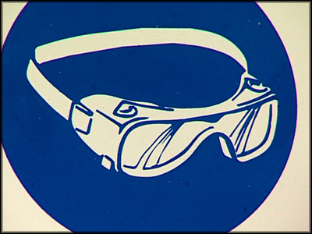
Gloves should be worn to prevent skin contact (pigments will stain).
Safety glasses and lab coats (aprons) should be worn at all times

There are 6 different solutions. Check labels when you mix them together!!

- Iron(III) chloride – FeCl₃
- Potassium ferrocyanide – K₄[Fe(CN)₆]
- Copper sulfate – CuSO₄.5H₂O
- Sodium carbonate - Na₂CO₃
- Cobalt chloride solution
- Disodium hydrogen phosphate – Na₂HPO₄

To make Prussian Blue:

- Measure 50ml of potassium ferrocyanide and put it in a beaker.
- Use a different measuring cylinder or rinse the one you have, and measure 50ml of iron chloride.
- Add this to the beaker containing the potassium ferrocyanide.
- Observe what happens.
- Flute a piece of filter paper so that it fits into the funnel. Put the funnel into the conical flask.
- Pour the solution into the funnel slowly.
- If there is any pigment left at the bottom of the flask, use a little water and swirl around flask. Filter this solution too.
- Leave the pigment to dry in the evaporating dish.

To make Malachite Green:

- Measure 50ml of sodium carbonate and put it in a beaker.
- Use a different measuring cylinder or rinse the one you have, and measure 50ml of copper sulfate.
- Add this to the beaker containing the sodium carbonate.
- Observe what happens.
- Filter and dry by the same method as for Prussian Blue.

To make Cobalt Violet:

- Measure 50ml of disodium hydrogen phosphate and put it in a beaker.
- Use a different measuring cylinder or rinse the one you have, and measure 50ml of cobalt chloride.
- Add this to the beaker containing the disodium hydrogen phosphate.
- Observe what happens.
- Filter and dry by the same method as for Prussian Blue.

Questions

1) What did you observe when mixing the two solutions to make Prussian Blue?
………………………………………………………………………………………………………………………………………………………………………………………………………………………………………………………………………………………………………………
2) What did you observe when mixing the two solutions to make Malachite Green that did not happened when you made the other pigments?
……………………………………………………..………….…………………………………
……………………………………………………..………….…………………………………
…………………………………………………..…………….…………………………………
3) What caused this effect?
……………………………………………………..……….……………………………………
……………………………………………………..……….……………………………………
……………………………………………………..………….…………………………………
4) In the pigments, it is usually the type of metal that makes them coloured.
Name the metals present in the 3 pigments you have made
…………………………………………………..……….………………………………………
……………………………………………………..….…………………………………………
……………………………………………………..….…………………………………………

